A Virtual Peripheral DTMF Dialer

INTRODUCTION

This document refers to the source code dtmf_gen_1_3.src.

Many telecom applications, such as auto-dialer's, telephone keypads and security systems, require DTMF generation for dialing and data transmission. Using two artificial sine wave virtual peripherals tied in with a PWM virtual peripheral, a Scenix SX microcontroller can very efficiently perform DTMF generation.

A telephone keypad is broken up into four rows and four columns for a total of 16 keys. Each of these rows and columns is assigned to a specific frequency. To generate a specific digit, the system needs to generate the frequencies corresponding to the row and column in which the digit resides.

 |  | High Band Frequencies (Hz)
 |  | 1209 | 1336 | 1477 | 1633
Low Band Frequencies (Hz) | 697 | 1 | 2 | 3 | A
Low Band Frequencies (Hz) | 770 | 4 | 5 | 6 | B
Low Band Frequencies (Hz) | 852 | 7 | 8 | 9 | C
Low Band Frequencies (Hz) | 941 | * | 0 | # | D

Table 1 – DTMF Keyboard matrix

The SX DTMF generation Virtual Peripheral is extremely efficient; the core software is only 89 words in length. The entire demo program is less than 500 words long, including string tables, UART Virtual Peripherals, delay routines, and other routines required to demonstrate the DTMF generation software.

To understand how the PWM, artificial sin generation, and UART VP's work, take a look at the documentation on these components from http://www.scenix.com. The DTMF generation virtual peripheral uses two artificial sin-generation VP's: one for the low frequency and one for the high frequency. It multiplies the high frequency amplitude by 1.25 (twist) and adds it to the low frequency amplitude, and outputs this value onto the PWM pin (D/A conversion.) The mainline routine handles the digit to frequency decoding, and the dial and pause times.

SOFTWARE FLOWCHARTS

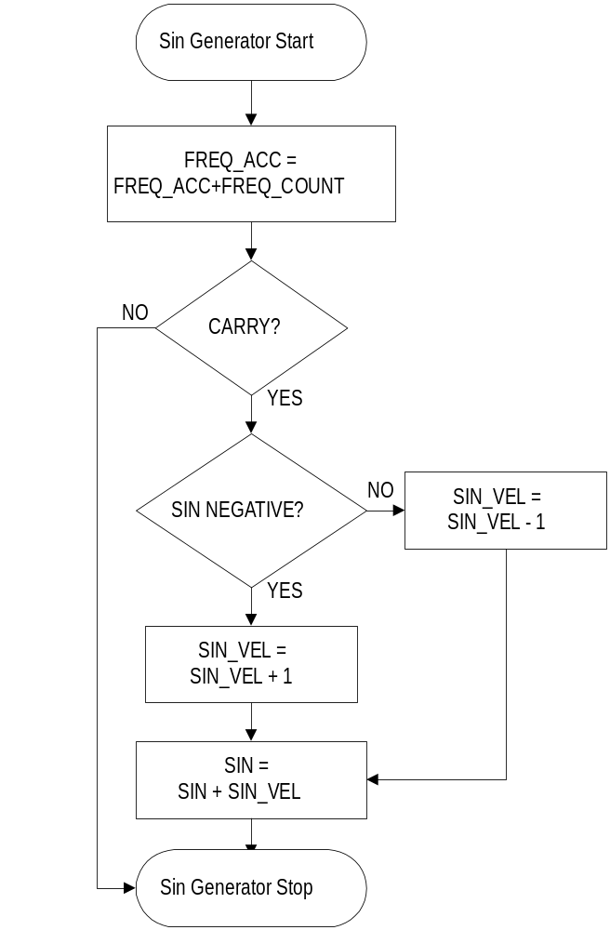Two Artificial Sin-Generator Virtual Peripherals are used in the DTMF generation software. This is the flowchart for each of them. The sin generators run in the interrupt service routine, transparent to the mainline routine.

SOFTWARE FLOWCHARTS

This is the flowchart for the interrupt service routine in the DTMF generation demo software. Although this flowchart shows that the UARTs are not run while DTMF generation is enabled, there is plenty of ovehead left to run the UARTs simultaneously.
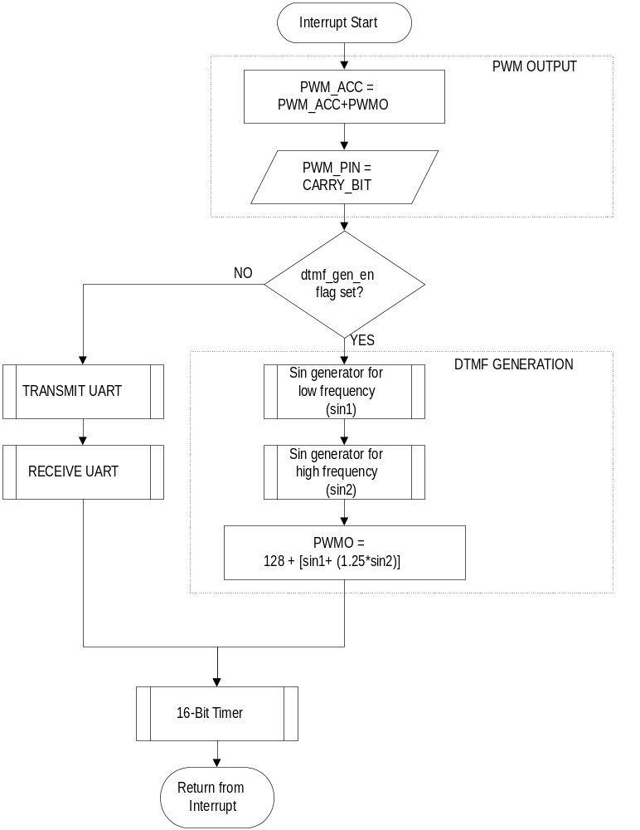
RUNNING THE DEMO

Running the demo is a snap with an SX DTMF DEMO board. If not, you can build a circuit to demonstrate DTMF generation.

Circuit Design
Vout
(To amplification and isolation circuitry)
Scenix SX
@ 50 Mhz
R
C
RS-232 Level Converter

To PC
rx_pin

pwm_pin

tx_pin

Depending on the maximum frequency you wish to obtain, you should adjust the component values for R and C to choose the resolution of the PWM. Ideally, you should calculate the maximum SIN frequency output you will use and choose the low-pass cutoff to be at this frequency. For DTMF generation, the maximum output frequency is 1633 Hz. To calculate the component values for a cutoff frequency of 1633 Hz:

First, choose a value for R.

R=600 ohms

Now, calculate C:

C = 1/(2 * pi * Cutoff Frequency * R)

Therefore:

C = 1/(2 * 3.14 * 1633Hz * 600 ohms)

And

C = 0.162uF

OPERATION:

An RS-232 interface is required to run the DTMF demonstration software as-is, although the program should be modular enough to change in order to bypass the RS-232 interface. For the RS-232 level conversion, a MAX232 IC will do the job. Information and samples are available on the world-wide-web from http://www.maxim-ic.com.

Your terminal program should be set up for 19200 bps, No Parity, 8 Data Bits, 1 Stop Bit.

Once you have connected power and are ready to demonstrate DTMF generation, reset the board. When you see the prompt, press 'd' to start dialing. Type characters such as '1', '2', '3' or '*' or '#' on the keyboard and the SX will dial each of these characters for a 100ms duration.

